LAB 11

The Z-Transform and the Discrete Time Fourier Transform

Jordan Hayes

EGR323: Signals and Systems Analysis

7/28/2021

Prof. Krug

**Introduction and Objectives**

The objectives of this laboratory are to use the Z-Transform as a way of simplifying the Fourier Transform of a discrete time signal. The signal is decomposed into its frequency components, and the resulting equations are a function of $ω_{o}$ and is limited to frequencies less than ½ of $f_{s}$, the sampling frequency. The Z-Transform can still be used to simplify convolution in time domain, and to shift and manipulate samples. The Discrete Fourier Transform will be used to extract frequency information from the Z-Transform. The basic equation for the Z-Transform is shown in Eq. (1)

$X\left(z\right)= \sum_{-∞}^{∞}{x\left(n\right)z^{-n}}$ (1)

The affects of $z^{-n}$ will be observed as well, where *z* can be written as

$z=re^{jω}$

Where *r* is the real magnitude of *z* and $ω$ is the phase; therefore, $z^{-n}$ can be written as

$z^{-n}={\left(re^{jω}\right)}^{-n}$ (2)

It can be shown that $z^{-n}$ can also be written as

$r^{-n}\cos\left(ωn\right)-jsin(ωn)$ (3)

As:

$z^{-n}={r^{-n}e}^{-jωn}$ (2a)

Then using Eq. (2), the exponential can also be described by a sinusoid.

$e^{jx}=\cos\left(x\right)+jsin\left(x\right)$ (5)

Substituting:

$z^{-n}=r^{-n}(\cos\left(-ωn\right)+jsin\left(-ωn\right))$ (2b)

Using cosine and sine identities, the equation simplifies to

$z^{-n}=r^{-n}(\cos\left(ωn\right)-jsin\left(ωn\right))$ (2c)

**Procedure and Results**

**Part I**

For this part, a cosine wave is created that is sampled eight times per period. The period of the cosine wave was chosen to be $\frac{π}{4}$.

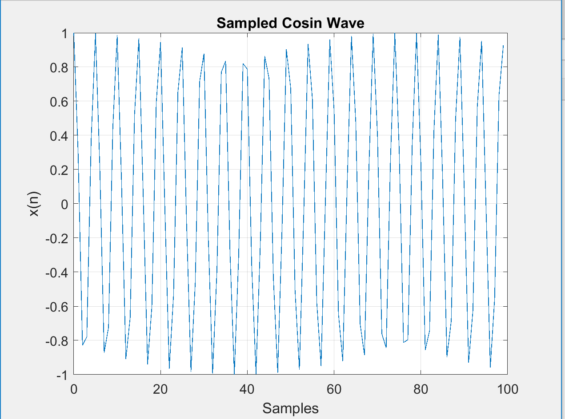

**Figure 1: 100 Samples of Chosen Cosine Wave**

The resulting waveform above has an angle of $\frac{π}{4}$ radians per sample. Next, 100 samples of the real portion, $r^{-n}$, with *r =.95* was plotted below.

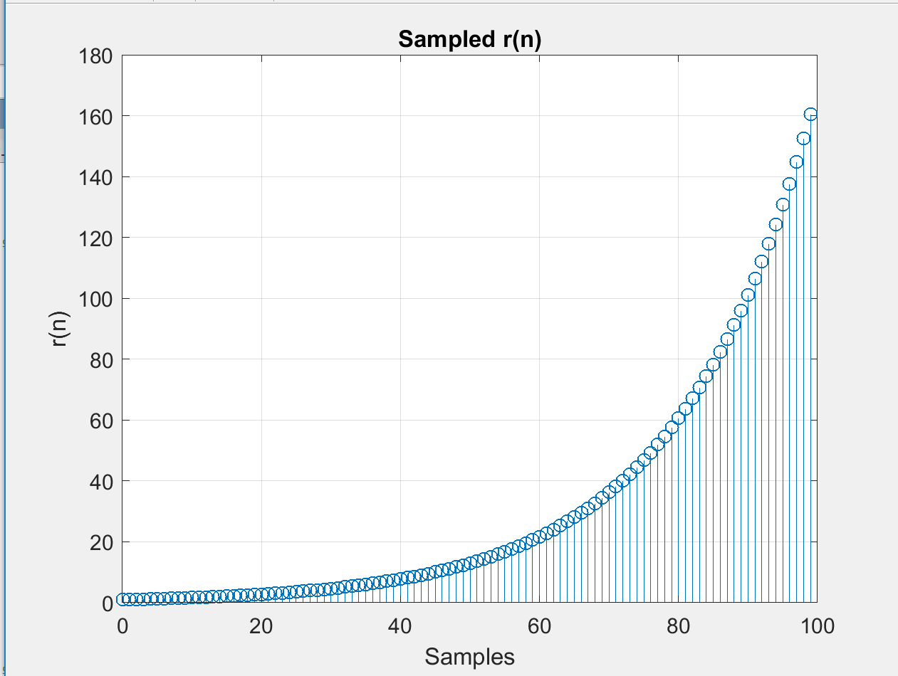g

**Figure 2: 100 Samples of $r^{-n}$ at r = .95**

The equations are multiplied together to create a form of Eq. (2c) with *r < 1*and is plotted below.

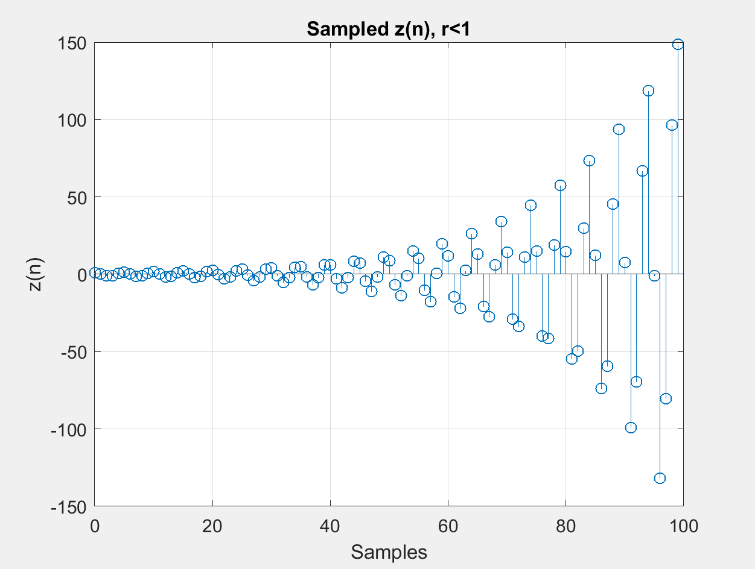

**Figure 3: 100 Samples of Figure 1 Multiplied by Figure 2 at r = .95**

The same steps are repeated from the sampled cosine function were then plotted with *r =1.05* which is greater than 1.

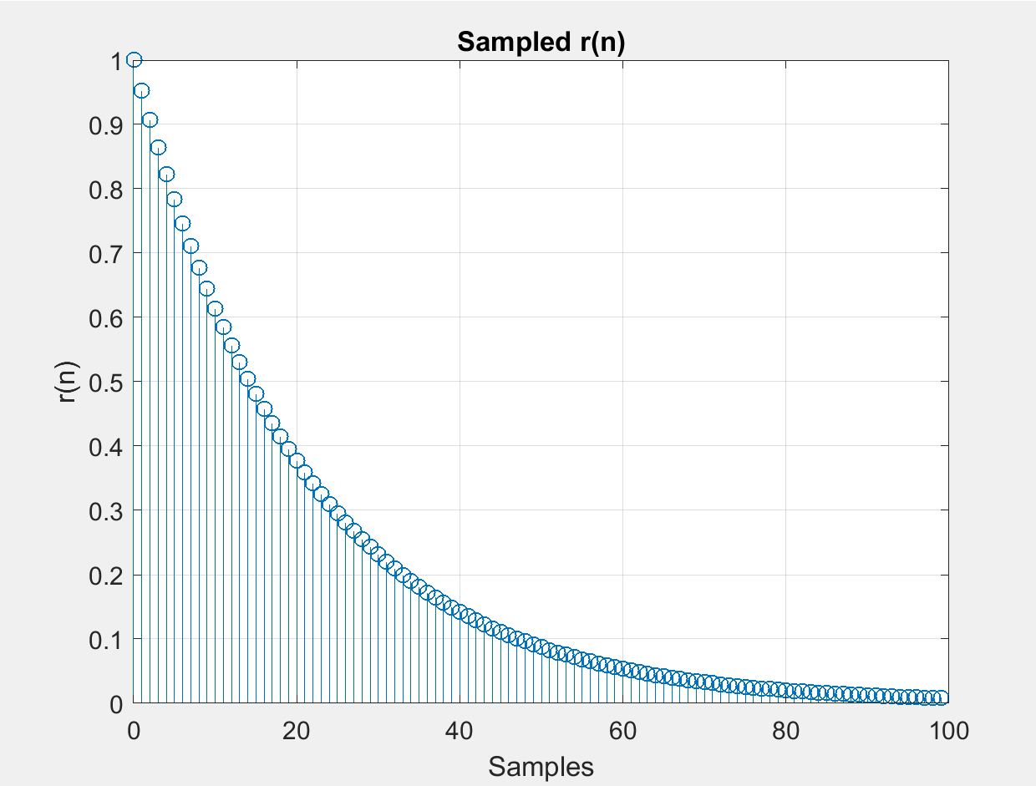

**Figure 4: 100 Samples of $r^{-n}$ at r = 1.05**

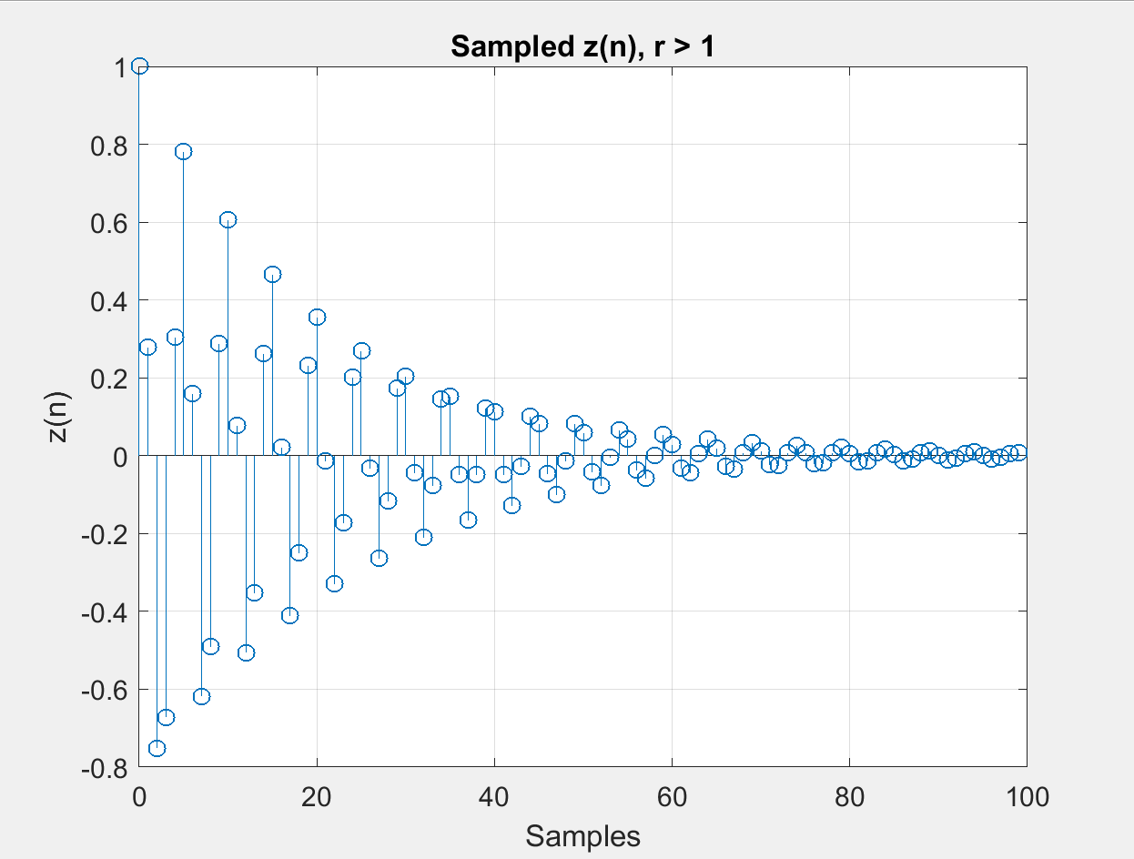

**Figure 5: 100 Samples of Figure 1 Multiplied by Figure 4 at r = 1.05**

The process is repeated for *r = 1.*

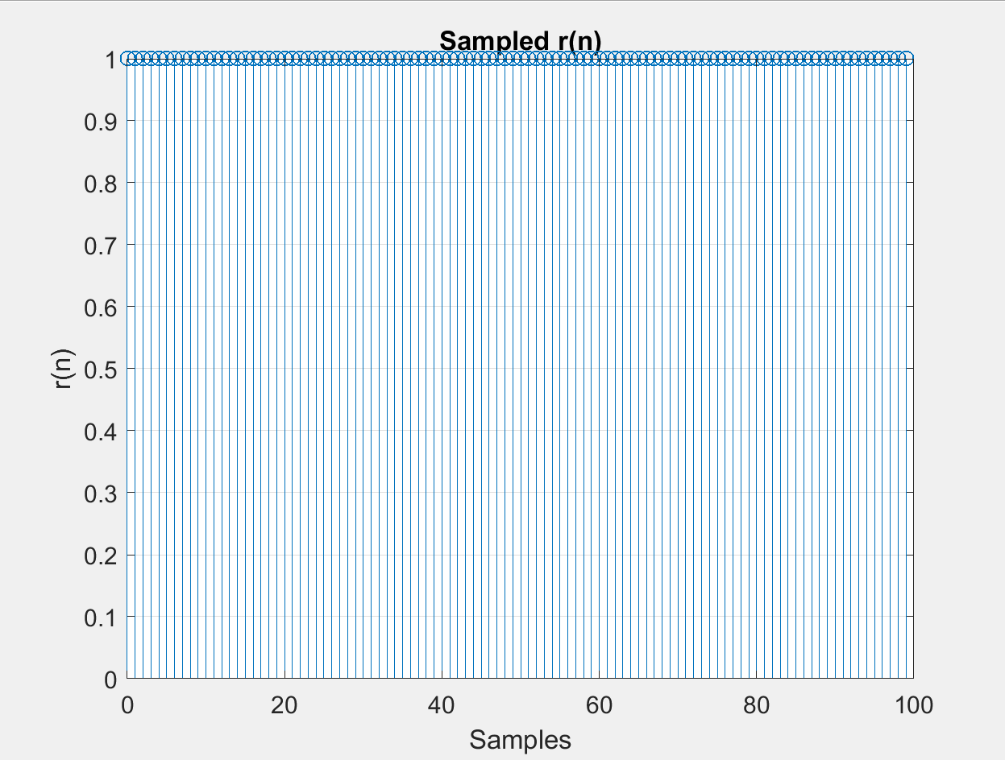

**Figure 6: 100 Samples of $r^{-n}$ at r = 1**

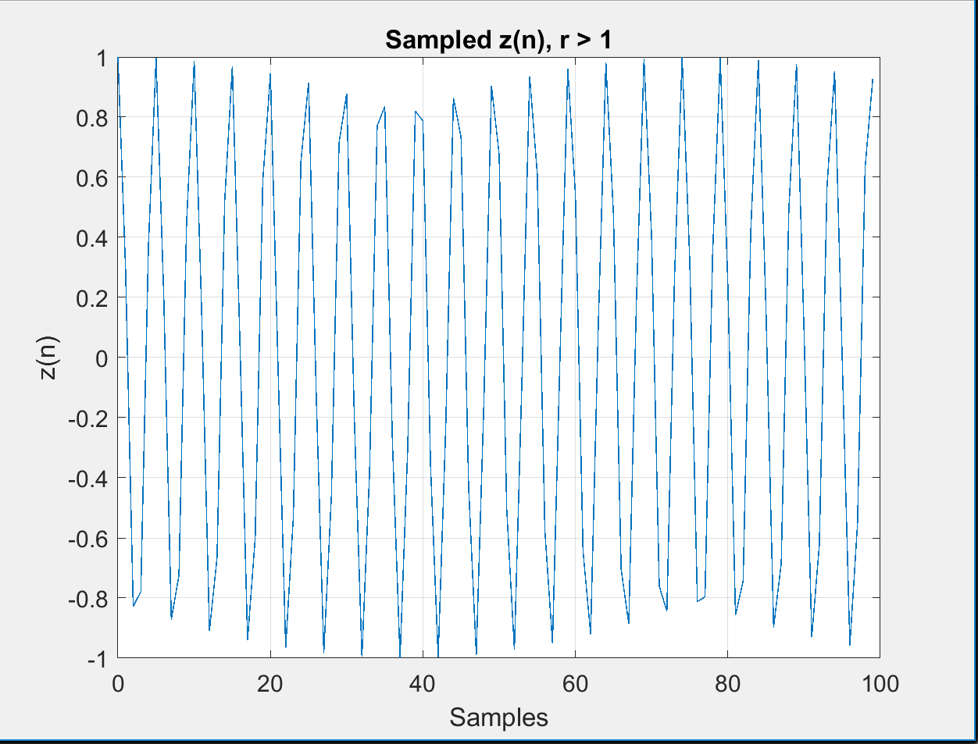

**Figure 7: 100 Samples of Figure 1 Multiplied by Figure 6 at r = 1**

From the plots, it can be concluded that a radius less than 1 creates a function that does not converge and goes to infinity; a radius greater than one creates a converging decay function. The original input is only sustained when *r = 1.*

**Part II**

This part involved using MATLAB to perform the z transform with symbolic variables using the *ztrans()* function. The following expressions were plotted.

$a) {(\frac{1}{10})}^{n}$

$b) sin⁡(ωn)$

$c) cos⁡(ωn)$

$d) e^{j4n}$

The results of the systems and z-transforms are listed in the corresponding order.

$a) \frac{z}{z-1/{10}}$

$b) \frac{z*sin⁡(ω)}{z^{2}-2zcos\left(ω\right)+1}$

$c) \frac{z*(z-\cos\left(ω\right))}{z^{2}-2zcos\left(ω\right)+1}$

$d) \frac{z}{z-e^{j4}}$

**Part III**

This part involved using the z-transform to create a complex zero/pole plot as well as generate the impulse response using the *zplane()* and *impz()* functions. The z-transforms were found to be the following.

$a) H\left(z\right)= \frac{z}{z^{2}-0.6z+1}$

$b) H\left(z\right)= \frac{z}{z^{2}-0.707z+0.25}$

$c) H\left(z\right)= \frac{z}{z^{2}-2z+1.5}$

The input arguments to the functions are the coefficients of the numerator and denominator. The z-plane plots and impulse response for each z-transform are shown below.

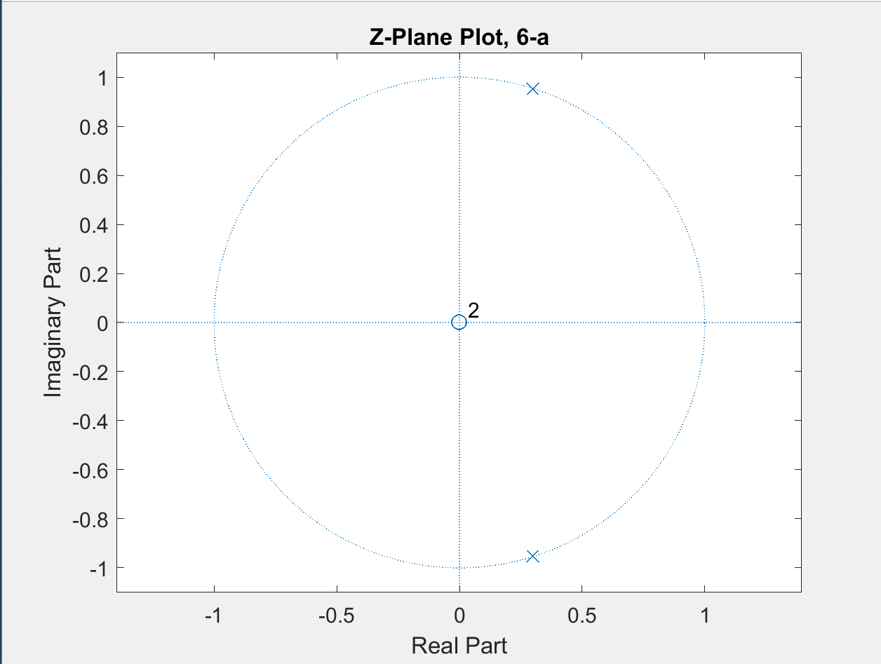

**Figure 8: Z-Plane Plot of System a)**

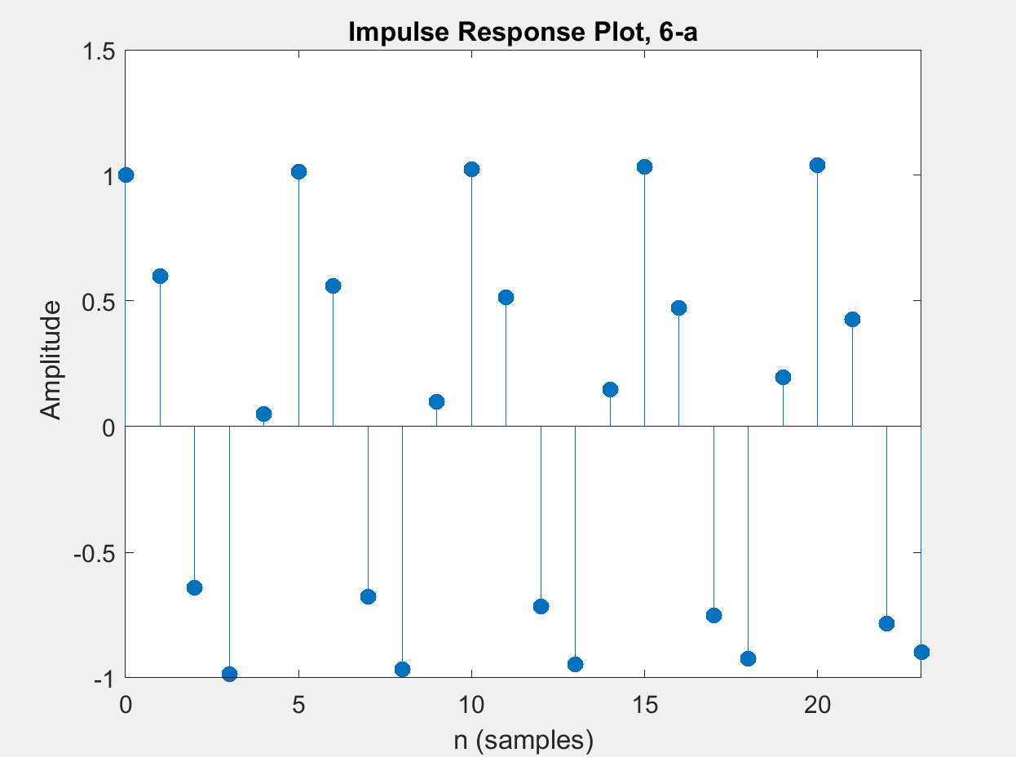

**Figure 9: Impulse Response of System a)**

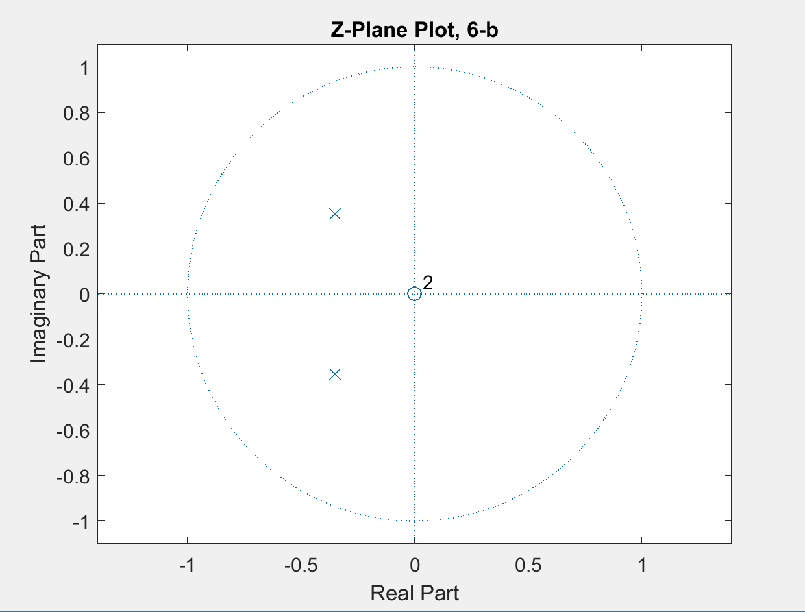

**Figure 10: Z-Plane Plot of System b)**

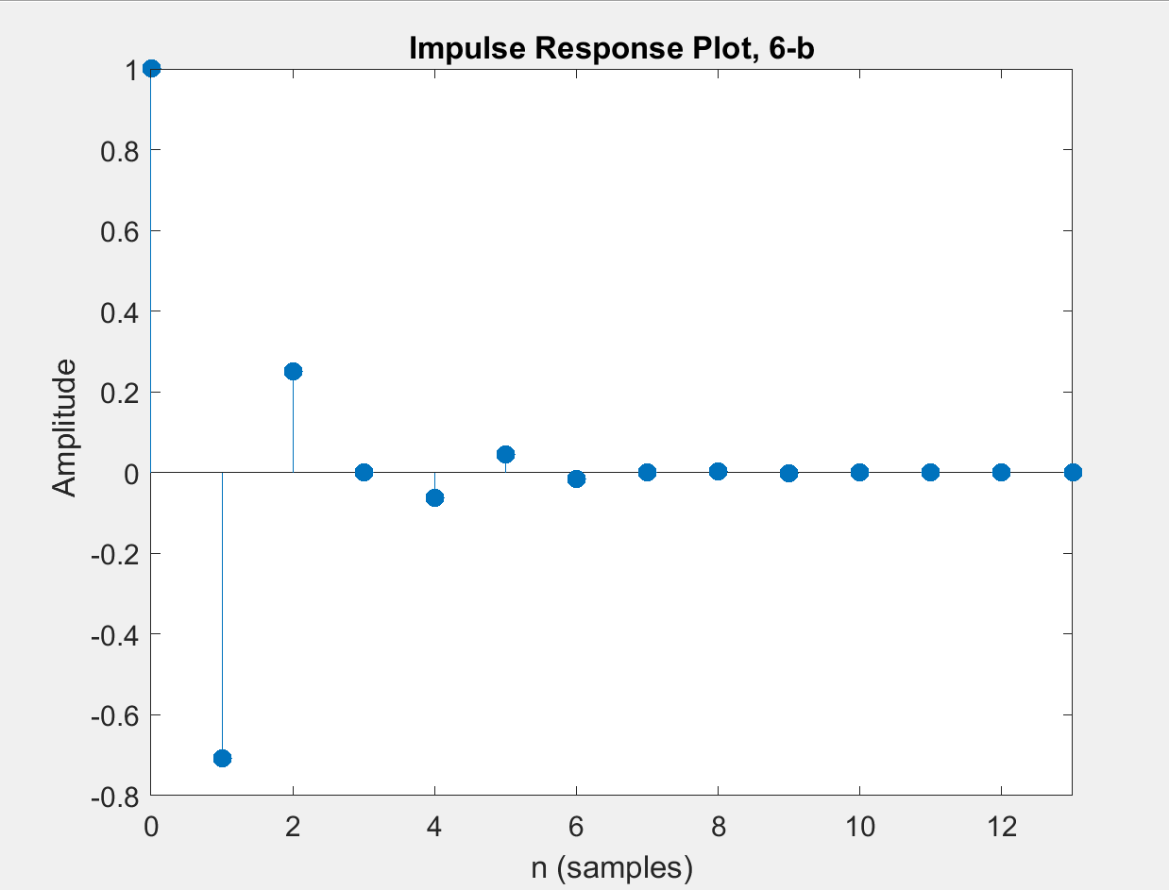

**Figure 11: Impulse Response of System b)**

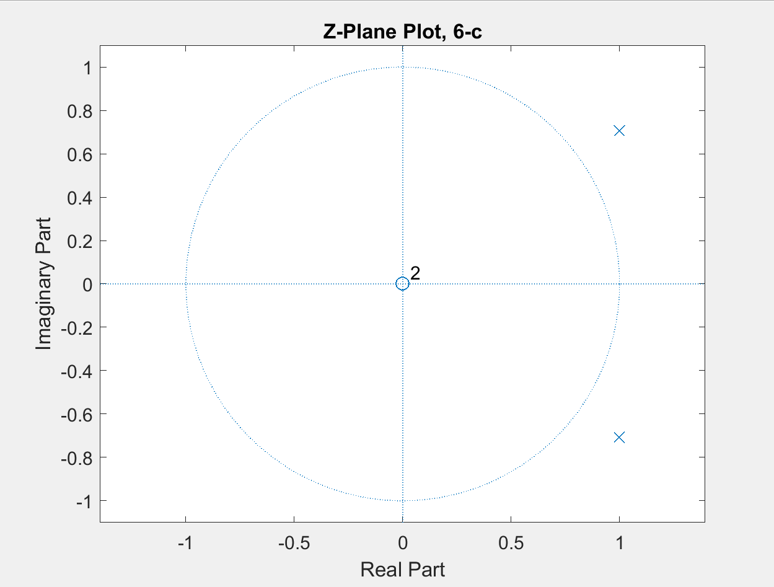

**Figure 12: Z-Plane Plot of System c)**

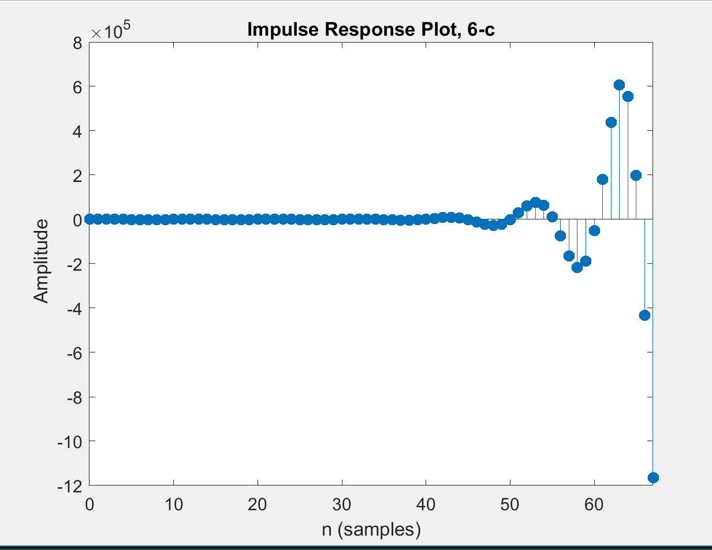

**Figure 13: Impulse Response of System c)**

The figures above show that if a pole lies on the radius of the circle in the z-plane, the system maintains its oscillation in the impulse response. If poles lie within the circle in the z-plane as in system *b),* they are dampened and converge to zero. Conversely, f a pole lies outside the circle as in system *c),* the impulse response becomes unstable and diverges to infinity.

**Part IV**

This part of the laboratory involved using the *freqz()* MATLAB function to plot the magnitude and phase response of the transforms from the former part. Figures and shownrespectively.

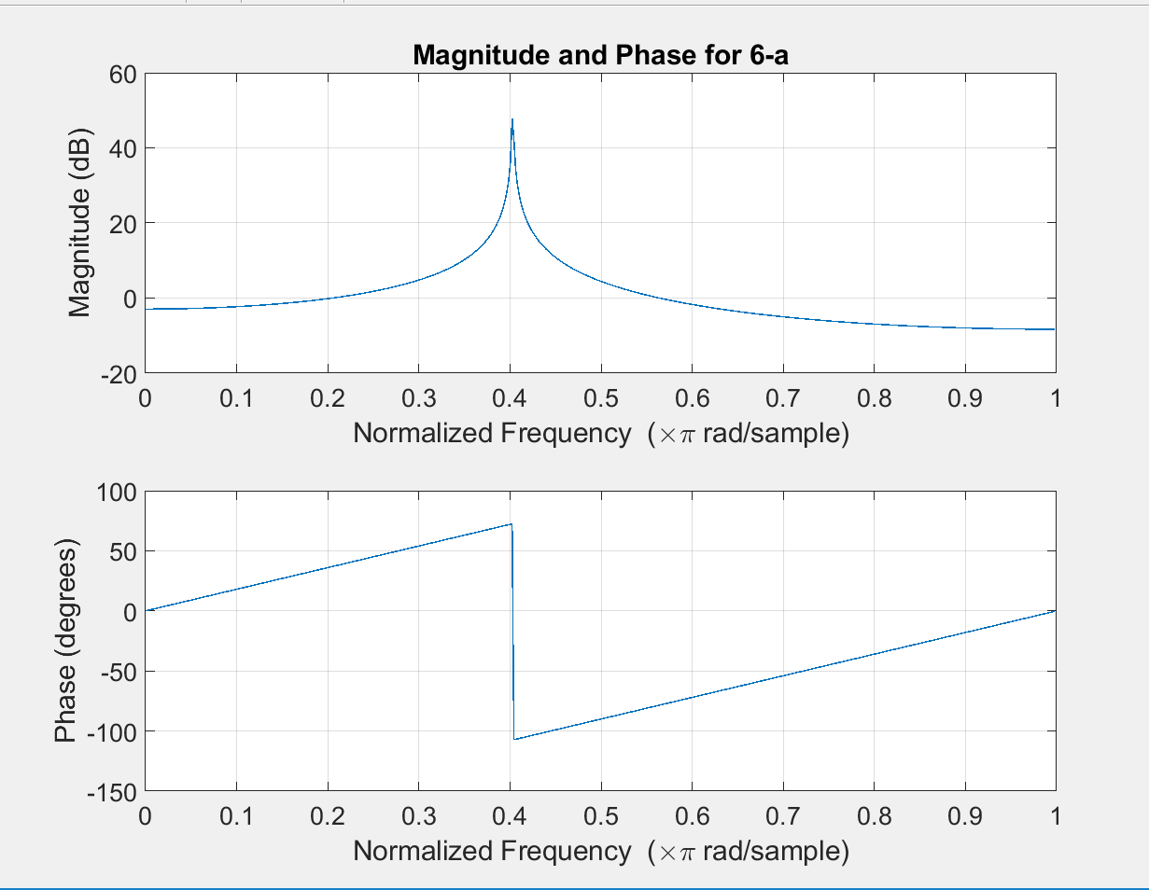

**Figure 14: Magnitude and Phase Plot of System a)**

At a sampling frequency of 1kHz, 500Hz is at .5 of the Normalized frequency axis, and 750Hz is .75. From the plot, 500Hz has a magnitude of 4.44 dB and a phase of -90 degrees. 750Hz has magnitude of -6.08 dB and a phase of -45.

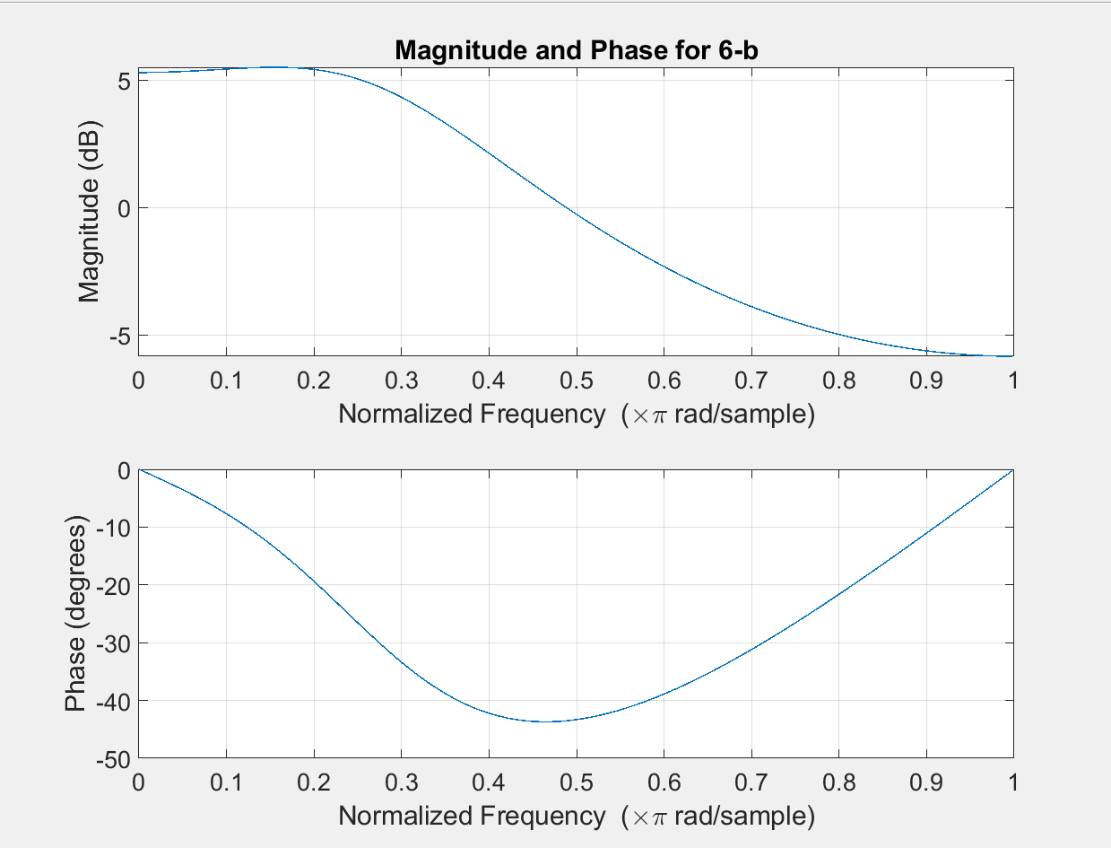

**Figure 15. Magnitude and Phase Plot of System b)**

The second system has a 500Hz magnitude of -0.263dB and -43.5 degree phase. The 750Hz signal has -4.49dB magnitude and -26.6 degree phase.

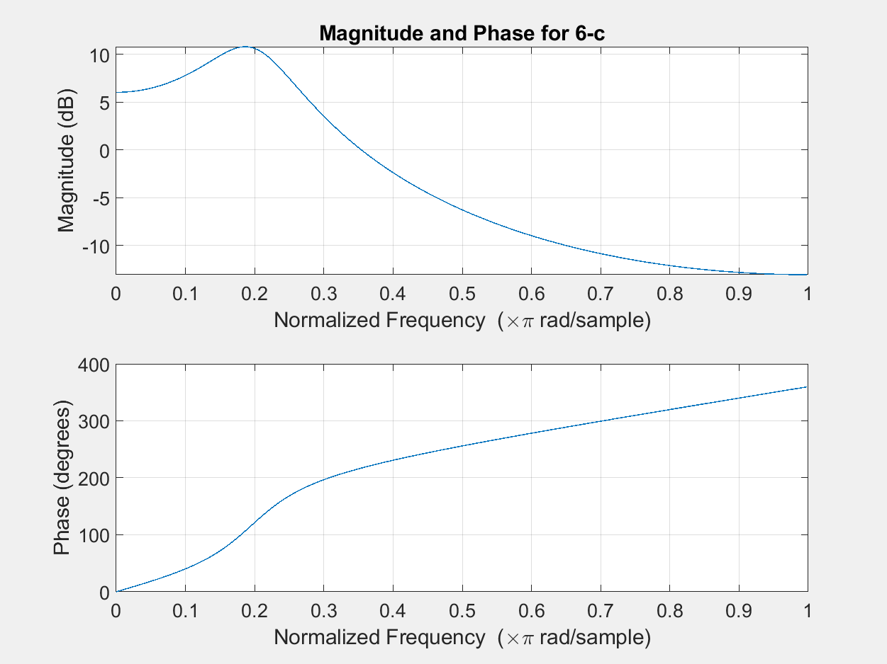

**Figure 16. Magnitude and Phase Plot of System c)**

The plot shows a -6.28dB magnitude response and 256 degree phase for 500Hz, and 750Hz shows a magnitude response of -11.6dB with a 309.6 degree phase.

**Conclusion**

The objectives of this laboratory were completed by exploring the characteristics of the z-transform. The radius of the z-transform representation determines whether the function will diverge to infinity for *r < 1,* converge to zero for *r > 1*, or maintain its oscillating behavior with *r=1.* This can also be shown in the complex z-plane where the position of the pole in reference to the circumference of the circle will also determine the behavior described above. MATLAB tools were used to calculate the z-transforms of multiple systems and plotting the z-plane waveform as well as the impulse response to convey these affects. The frequency magnitude and phase response of the z-transform were also plotted on a normalized frequency axis so that any given sample frequency, all smaller frequencies can be mapped.